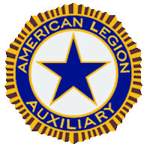

Community Service Report Form
Department of North Carolina
DUE APRIL 15, 2023

Mary Thorsten 1 Gate 10 Carolina Shores, NC, 28467
mayree1979@gmail.com 760-421-1512

Faith Family Freedom

Unit Name: ________________________________________________ Unit Number____________
Name of Chairman:__________________________________________________________________
TOTAL NUMBER OF HOURS: __________________ TOTAL DOLLARS SPENT: __________________
List projects Unit did in your Community: (Please include photos and details on a separate sheet, if necessary)
_________________________________________________________________________________
_________________________________________________________________________________
_________________________________________________________________________________

List projects Unit SPONSORED in your community: _______________________________________
__________________________________________________________________________________

