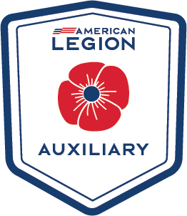
RULES FOR SENIOR AND
JUNIOR SCRAPBOOKS
American Legion Auxiliary
Department of North Carolina
2024-2025

INTRODUCTION 10 points
Must have Title page with unit name, number and Scrapbook Chair
Must have picture of Unit President with name Include list of any unit members serving on the Department and National levels.

APPEARANCE 50 points
Use a binder with Auxiliary Emblem on it.
It cannot be smaller than 8 ½ X 11 inches.
All photos should be identified with names of the persons in them & name of the event.
All newspaper clippings and/or articles must be identified with the name of the paper or publication and date of printing.
Neatness counts.
Be creative and have fun!

ARRANGEMENT 40 points
Needs to be in chronological order

DEADLINE
Unit Senior Scrapbooks should be entered at the June 2025 Dept Convention BEFORE NOON ON FRIDAY.

Junior Scrapbooks should be entered at the 2025 Junior Meeting.

