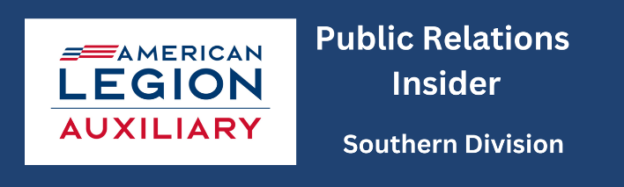
2024 – 2025 Leadership Program Engagement Plan

Betty Moore, Chairman moorebetty56@yahoo.com
Wanda Moore, wexumm@yahoo.com
Betsey Lee Hodges, hbetseylee@gmail.com

- Attend Mission Training in Nashville, TN
- Attend department conferences, division & district meetings and leadership trainings/zoom meetings to learn about the 3 keys for leadership and other information
- Look for leadership opportunities in your community where members can seek veteran support, inform high school students about veterans, and locate other avenues where individuals can build their leadership skills
- Nominate a Unit Member of the Year from your unit
- Participate in at least 2 ALA Academy courses
- Participate in the National’s Leadership Certificate Program
- Picture evidence of unit members using leadership resources
- Sign up for Leadership Newsletters

2024 – 2025 Awards
- Unit Member of the Year Award
- District President of the Year
- Division President of the Year
- Chairman of the Year
- Most Outstanding Unit Leadership Program

2024 – 2025 Leadership End of Year Report
Betty Moore Chairman moorebetty56@yahoo.com
Wanda Moore, wexumm@yahoo.com Betsey Lee Hodges, hbetseylee@gmail.com
Please return to Betty Moore, 1063 Riverside Circle, Eden, NC 27288
Or email moorebetty56@yahoo.com Phone 336.623.5150
Unit Report & Unit Member of the Year Report Due April 30, 2025
Name and number of Unit_____________________________ District_______ Division_______
Member completing the form_____________________________________ Phone____________
- How many members attended the ALA Mission Training? ________ What did the members think of the presentation, and did they share it with unit members?

- How many members attended:
Division Meeting ______Fall Conference ______Mid-Winter Conference ______
District Meeting_______ Leadership trainings/zoom meetings______ What did the members think of these events?

- How many members participated in seeking Leadership opportunities:
- to gain veteran support? _____
- to assist high school students in learning about veterans? _____
- to locate other avenues where individuals could build their leadership skills? _____
- what activities were done?

- Did your unit submit a nomination for American Legion Auxiliary Unit Member of the Year Award? Please tell who it is and why the selection was made.
- As Unit President, did you promote the ALA Academy? Yes____ No____ Number of members participating in at least 2 ALA Academy Courses ____Which courses were selected?

- How many members participated in the National’s Certificate Leadership Program? _____ and what activities did each member complete?
- Does your unit have a copy and how many members have copies of the following resources? ____ Did you submit a picture of members using any of these resources? Yes____ No____
ALA Unit Guidebook Yes____ No____
National Constitution and Bylaws Yes____ No ____
Department Constitution and Bylaws Yes____ No____
Department Operations Guide Yes____ No____
Parliamentary Procedure Yes____ No ____
Other ALA guides Yes____ No ___

- How many members signed up for the Leadership Newsletter and Zoom meetings? Newsletter____ Zoom Meetings____

