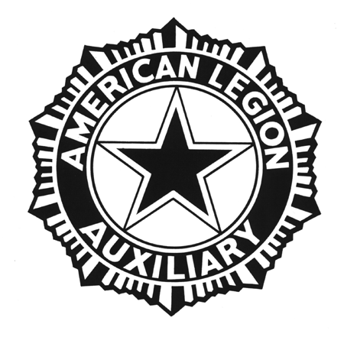
Veterans Affairs & Rehabilitation
Department of North Carolina
Year End Report 2023-2024

Due to Chairman by - April 30, 2024

For a Unit award you must submit a year-end Unit narrative report, please complete this section. Be sure to give the complete name of your Unit. The award certificate will be prepared using the information you include below.

Unit #: ________ Full official Unit Name:_______________________________________________

Unit President/Chairman (circle one) Name_______________________________________________

Above listed person’s ALA member ID#: _______________ Phone Number: (____)_______________

Email Address: _____________________________________________________________________
Did your Unit participate the following programs if so, please list the hours and amount spent.

Operation Comfort Warriors ____________________________________________________________
Community/Hospital Stand Downs _______________________________________________________
Creative Arts Festival _________________________________________________________________
Veterans in the Classroom _____________________________________________________________
Volunteer at a VA Medical Center or Nursing Home __________________________________________
Did your Unit host any function for veterans_________________________________________________
Cook or care for a home bound veteran ___________________________________________________
Veterans Food Bank __________________________________________________________________
VA&R Fair Share donation, amount donated ________________________________________
Special Funds for VA Hospital if so, amount donated__________________________________

We ask that you do a narrative report on the activities your Unit has done during the year along with photos of your activities. This helps us give an accurate report to the National office on how our Department is participating in the programs.
Mail to:
Lolita Jenkins, Chairman
324 Rockyford St.
Morganton, NC 28655
Phone: 828-467-7547

