

**Remember to Wear Your “Be The One” Shirt on the first of every month.**

Be The One” crisis #988 and press 1. Counselors are available 24/7 or text 838255. Remember, the objective of the Be The One Campaign is to prevent suicide. The Legion Family reaffirms our commitment to the 'Be the One' Mission this year. We will continue our efforts to prevent suicide through the 'Be The One' Mission. Remember, counselors are available 24/7, or you can text 838255 for support. Together, we can make a Difference.

Remember to wear Red on Fridays to remember all military men and women deployed.

**Dates to Remember**

**American Legion World Series**

**August 14-19**

**National Convention August 22-2 Tampa Flordia.**

**2 Timothy 2:5: If anyone competes in athletics, they are not crowned unless they compete according to the rules**.

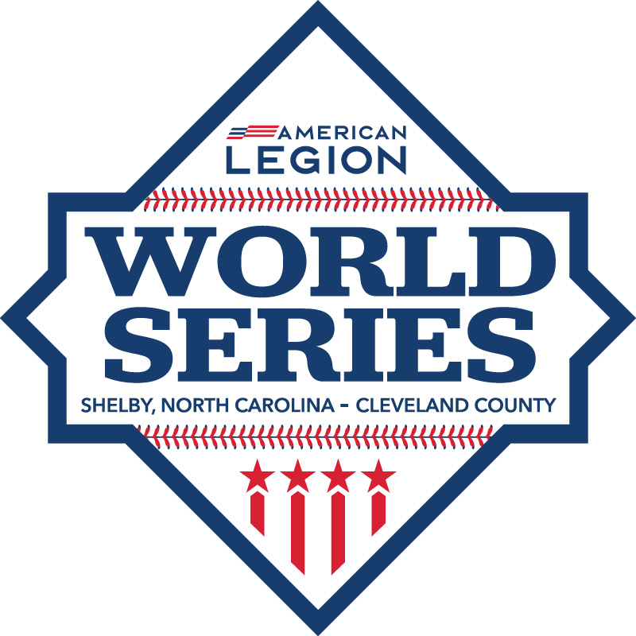

**100 Years of American Legion Baseball**

**1925-2025**

Can you smell the popcorn? Nothing says summer in my hometown like American Legion Baseball. Some of my favorite summer memories as a kid are around American Legion Baseball. It’s still a big part of my summer. The American Legion Baseball program started when the American Legion introduced baseball at its 1925 South Dakota convention, with the first national tournament held in 1926. By 1929, teams from every state and the District of Columbia took part. The program has grown to include over 10 million players and remains a key part of character-building and citizenship training. According to the American Legion, the goal of American Legion Baseball is to give players "an opportunity to develop their skills, personal fitness, leadership qualities, and to have more fun." In 2011, Shelby, North Carolina, was named the permanent home of the American Legion World Series after decades of rotating venues for the event.

For more details, see the Legion Baseball Bookazine, now available at emlem.legion.org.

Julie

|  |  |  |
| --- | --- | --- |
|  |  |  |

**From the Americanism Chair, Celeste Slater**

The AL Auxiliary mission is service, not self, and is in full gear when it comes to Legion Baseball.

Working behind the scenes, managing baseball registration, buying food for the concession stand, ensuring the dugouts are stocked with plenty of cold water for both teams, canvassing local businesses for ads in the team program booklet, and handling the PR for each game (before and during).

Game Day, you are likely to be greeted by an Auxiliary member collecting gate receipts, managing the merchandise table, accepting donations for the program booklet, cooking, and taking your order at the concession stand. Auxiliary members are usually the loudest cheerleaders in the stands. They strike up conversations with players' family members and others at the game. They also serve as recruiters for new members of the American Legion Family. Sometimes, an Auxiliary member is the field nurse who cleans scrapes and bandages an injured ballplayer after sliding into base. What is more American than apple pie, baseball, and the American Legion Auxiliary?

**.**

|  |  |
| --- | --- |
| |  | | --- | |  | |

|  |  |
| --- | --- |
| |  | | --- | |  | |