**2024 - 2025 Constitution & Bylaws Program Engagement Plan**

Betsey Lee Hodges, Chairman

Carol Barker, Michelle Potuzak, Lynn Purely, and Beverly Williams

1. **Review** your Unit Constitution & Bylaws, Standing Rules
2. Unit C&B, Standing Rules cannot conflict with the National or Department C&B, Standing Rules.
3. When changes are made in the National or Department C&B, Standing Rules, the same changes must be made in the units’ C&B, Standing Rules.
4. **Update** your Unit Constitution & Bylaws, Standing Rules
5. Changes [amendments] to your documents are made as motions or resolutions where you move to strike out, add or substitute words or paragraphs in the current wording of the document.
6. The National Constitution and Bylaws may be amended at any National Convention by a two-thirds vote of the National Convention delegates provided the proposed amendments have been distributed to the Departments and NEC members 20 days prior to the convention. Amendments proposed after distribution may be adopted by a two-thirds vote of the National Convention delegates, provided they have been read at one session of the National Convention prior to taking the vote.
7. Certain National Standing Rules, [Constitution Article VI. Section 2, Bylaws Article VI. Section 3, and Bylaws Article X. Section 1] can only be amended or rescinded by action of the National Convention delegates; otherwise, national standing rules may be amended or rescinded by a two-thirds vote of the NEC or National Convention delegates or, if notice has been given, by a majority vote.
8. The Department Constitution and Bylaws may be amended at any Department Convention by a two-thirds vote of the Department Convention delegates provided the proposed amendments have been distributed to the Units and DEC members 20 days prior to the convention. Amendments proposed after distribution may be adopted by a two-thirds vote of the Department Convention delegates, provided they have been read at one session of the Department Convention prior to taking the vote. An amendment not having been previously read or distributed may be adopted by unanimous vote of the Department Convention delegates.
9. A Department Standing Rule may be amended or rescinded by a two-thirds vote, or if notice has been given, by a majority vote.
10. **Consider** adding these or other Standing Rules
11. Members of the ALA may use and distribute names and contact information of its membership for official use only within the ALA.
12. A member failing to pay annual dues by January 31st of the current membership year shall be delinquent and suspended from membership privileges.
13. A description of the Unit’s process for the discipline of members.
14. Unit procedures for handling emergencies, disasters and/or violence at your post.
15. **Sign up** for C&B Newsletters & participate in training/zoom meetings if offered.
16. **Provide** a copy of your unit’s C&B, SR to all unit members.

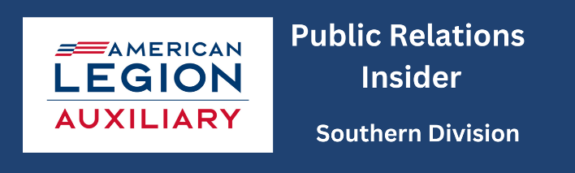**2024-2025 Constitution and Bylaws End of the Year Report**

**Please return to Betsey Lee Hodges, 102 Dogwood Drive, Washington, NC 27889-5410**

**Or email** [**hbeteylee@gmail.com**](mailto:hbeteylee@gmail.com) **Phone 252.833.9578 Report Due April 30, 2025**

**Name and number of Unit_____________________________ District_______ Division_______**

**Member completing the form_____________________________________ Phone____________**

Did your unit review and update your Constitution & Bylaws? Yes__ No__ If so, what changes did you make and how many members worked on it?

Did your unit sponsor any Constitution & Bylaws activities, projects or events? Yes__ No__ If so, what was sponsored and how many activities, projects or events were done? Please be specific.

Did your unit participate in any Constitution & Bylaws trainings or zoom meetings sponsored by the Department? Yes__ No__ If so, what did you learn that you did not know? How many members participated?

Did your members sign up for the Constitution & Bylaws newsletter sponsored by the Department? Yes__ No__ If so, what was the best thing you learned? Please be specific.

Do you provide a copy of your Constitution & Bylaws for your unit members? Yes__ No__ If so, how was it delivered?