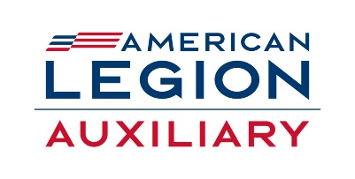
2023 – 2024 CHILDREN and YOUTH
PROGRAM ENGAGEMENT PLAN

Chairman: Dolly L. Fisher, DLFisher52@gmail.com 585-451-6904
Member: Dorothy Brower, dab811@embarqmail.com 919-599-6605
Member: Helen Faison, faisonhm@aol.com 910-990-1319

The American Legion Auxiliary works collaboratively with the American Legion to promote programs that protect and support children and youth, especially those of our military and veterans.

The National initiatives of focus this year are:
YOUTH HERO AWARD
This young person could a Junior Auxiliary member or someone who is eligible for membership. (Membership is NOT a requirement for this award).
This young person demonstrates a physical act of valor. ( Heimlich, CPR, first aid, etc.)
This young person serves as an inspirational role model for the organization and the community.
Guidelines: This award is presented to a young person under the age of 18 years who has performed an act of physical valor.
AWARD: Youth Hero Award Citation
The nominating unit will need to complete the Good Deed Award Nomination form (available online) and mail it the Department Secretary, who will certify the nomination and forward to National Headquarters. ( DO NOT MAIL DIRECTLY TO NATIONAL.)
GOOD DEED AWARD
This young person can be a Junior Auxiliary member or someone who is eligible for membership. ( membership is not a requirement for this award. )
This young person donates their time and/or money for a worthy cause (such as troop support, raising money for homeless veterans, food drives, etc.)
Guidelines: Same as the Youth Hero Award
Award: Citation

KIDS of DEPLOYED are HEROS 2
This initiative honors the military children who may be experiencing a separation from one or both parents, whether deployed to a war zone, having a short tour or extended temporary assignment.
Recognition buttons or stickers with “I’m a Hero 2” can be distributed to these kids to recognize their sacrifices.

The American Legion Auxiliary Children and Youth Committee strives to support and promote the Children and Youth program of The American Legion. You are encouraged to work with your Post to care for our children.

Please feel free to contact me with any questions or for more information at 585-451-6904 or email me at DLFisher52@gmail.com.

